07. Graph

- Introduction

A graph G = (V, E) consists of a set of vertices V and a set of edges E. Each edge is a pair (v, w), where v, w ∈ V. if the pair is ordered, the graph is directed. A directed graph is acyclic if it has no cycles. In a graph, if the number of edges is close to the maximal number of edges, the graph is called a dense graph; otherwise, it is called a sparse graph. A complete graph is a graph in which there is an edge between every pair of vertices.

There are two ways to represent a graph: adjacency matrix and adjacency list. In adjacency matrix, we use a two-dimensional array to represent the graph. For each edge (u, v), we set A[u][v] to 1; otherwise A[u][v] = 0. If the edge has a weight associated with it, we can set A[u][v] = weight and use either a very large or a very small weight as a sentinel to indicate nonexistent edges.

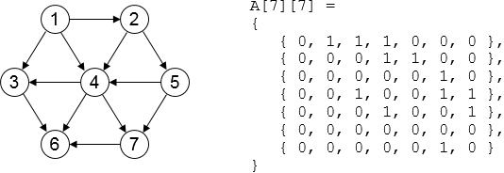

In adjacency list, for each vertex, we keep a list of all adjacent vertices. This is the standard way to represent graphs.

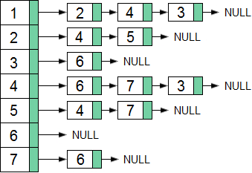

- Topological Sort

A topological sort is an ordering of vertices in a directed acyclic graph, such that if there is a path from v_{i} to v_{j}, then v_{j} appears after v_{i} in the ordering. The topological sort can be used to represent the course prerequisite. A directed edge (u, v) indicates that course u must be completed before course v.

A simple algorithm to find a topological ordering is:
- Find any vertex with no incoming edges, print this vertex, and remove it along with its edges from the graph.
- Apply the same strategy to the rest of the graph.

A topological sort is not possible if the graph has a cycle. Furthermore, the ordering is not necessarily unique. There may be more than one legal ordering. For example, the topological ordering of the graph above can be { 1, 2, 5, 6, 3, 7, 6 } and { 1, 2, 5, 6, 7, 3, 6 }.

To implement this, we can add an indegree field which indicates the number of edges that goes to the node. We also use a queue to hold all the vertices whose indegree is 0.
- When the queue is not empty, a vertex is removed, and all adjacent vertices have their indegrees decremented.
- A vertex is put on the queue as soon as its indegree falls to 0.
- The topological ordering then is the order in which the vertices dequeue.

The following shows the steps to apply topological sort to the graph.

vertex | 1 | 2 | 3 | 4 | 5 | 6 | 7 | queue | dequeue
indegree | 0 | 1 | 2 | 3 | 1 | 3 | 2 | 1 | 1
indegree | 0 | 0 | 1 | 2 | 1 | 3 | 2 | 2 | 2
indegree | 0 | 0 | 1 | 1 | 0 | 3 | 2 | 5 | 5
indegree | 0 | 0 | 1 | 0 | 0 | 3 | 1 | 4 | 4
indegree | 0 | 0 | 0 | 0 | 0 | 2 | 0 | 3, 7 | 3
indegree | 0 | 0 | 0 | 0 | 0 | 1 | 0 | 7 | 7
indegree | 0 | 0 | 0 | 0 | 0 | 0 | 0 | 6 | 6

- Dijkstra's Algorithm

Dijkstra's Algorithm is used to find the shortest path from a vertex to all the other vertices in a graph.
- Let S = V, dist[v] = 0, dist[v_{i}] = ∞, path[v_{i}] = { }, for each v_{i} ∈ V and v_{i} ≠ v.
- If S is empty, then done.
- Find the vertex u ∈ S, such that dist[u] = min(dist[v_{i}]), and let S = S – {u}.
- For each vertex v_{i} ∈ S, do the following, where w[u][v_{i}] is the weight over edge (u, v_{i}).
if (dist[u] + w[u][vi] < dist[vi])
{
dist[vi] = dist[u] + w[u][vi];
path[vi] = 'u';
}

- Go to step 2.

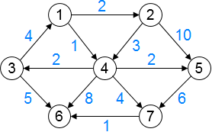

The following shows how to use the Dijkstra's Algorithm to find the shortest path from v₁ to all the other vertices.
- Initialization: S = { 1, 2, 3, 4, 5, 6, 7 }, dist = { 0, ∞, ∞, ∞¸ ∞, ∞, ∞ }, path = { 0, 0, 0, 0, 0, 0, 0 }.
- Vertex 1 is selected: S = { 2, 3, 4, 5, 6, 7 }, dist = { 0, 2, ∞, 1¸ ∞, ∞, ∞ }, path = { 0, 1, 0, 1, 0, 0, 0 }.
- Vertex 4 is selected: S = { 2, 3, 5, 6, 7 }, dist = { 0, 2, 3, 1¸ 3, 9, 5 }, path = { 0, 1, 4, 1, 4, 4, 4 }.
- Vertex 2 is selected: S = { 3, 5, 6, 7 }, dist = { 0, 2, 3, 1¸ 3, 9, 5 }, path = { 0, 1, 4, 1, 4, 4, 4 }.
- Vertex 3 is selected: S = { 5, 6, 7 }, dist = { 0, 2, 3, 1¸ 3, 8, 5 }, path = { 0, 1, 4, 1, 4, 3, 4 }.
- Vertex 5 is selected: S = { 6, 7 }, dist = { 0, 2, 3, 1¸ 3, 8, 5 }, path = { 0, 1, 4, 1, 4, 3, 4 }.
- Vertex 7 is selected: S = { 6 }, dist = { 0, 2, 3, 1¸ 3, 6, 5 }, path = { 0, 1, 4, 1, 4, 7, 4 }.
- Vertex 6 is selected: S = { }, dist = { 0, 2, 3, 1¸ 3, 6, 5 }, path = { 0, 1, 4, 1, 4, 7, 4 }.

The following shows the pseudocode.

function Dijkstra(Graph, source)
{
create vertex set S

for each vertex v in Graph:
dist[v] ← INFINITY
path[v] ← UNDEFINED
add v to S

dist[source] ← 0

while S is not empty:
u ← vertex in S with min dist[u]
remove u from S

for each neighbor v of u:
alt ← dist[u] + length(u, v)
if alt < dist[v]:
dist[v] ← alt
path[v] ← u

return dist[], path[]
}

The time complexity of Dijkstra’s Algorithm is O(n²), where n is the number of vertices.

- Minimum Spanning Tree

A minimum spanning tree of an undirected graph G is a tree formed from graph edges that connects all the vertices of G at lowest total cost.

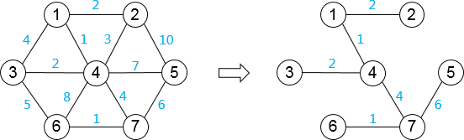

Two algorithms can be used to select a minimum spanning tree: Prim’s algorithm and Kruskal’s algorithm. Prim’s algorithm is optimal for dense graphs, whereas Kruskal’s algorithm is optimal for sparse graphs.

Prim’s Algorithm

At any point in the Prim's algorithm, we have a set of vertices that have already been included in the tree; the rest of the vertices have not. The algorithm then finds, at each stage, a new vertex to add to the tree by choosing the edge (u, v) such that the cost of (u, v) is the smallest among all edges where u is in the tree and v is not.

Let G = (V, E), dist[i][j] be the distance over vertex i and j.
- Choose a vertex v₀ and let S = { v₀ } and T = { }.
- If |S| = n, then stop.
- Choose the edge (u, v) ∈ E, where u ∈ S and v ∈ (V – S), such that dist[u][v] = min(dist[v_{i}][v_{j}]), for all v_{i} ∈ S and v_{j} ∈ (V – S).
- Let S = S ∪ { v } and T = T ∪ { (u, v) }. Go to step 2.

After the algorithm terminates, the collection T will be: { (1, 4), (1, 2), (4, 3), (4, 7), (7, 6), (7, 5) }. The time complexity of Prim’s Algorithm is O(n²), where n is the number of vertices.

Kruskal's Algorithm

Kruskal’s algorithm selects the edges in order of smallest weight and accept an edge if it does not cause a cycle.
- Let T = { }.
- If |T| = n – 1, then stop.
- Find the edge (u, v) ∈ (E – T), such that dist[u][v] is the smallest in all edges in (E – T) and T ∪ { (u, v) } does not have a cycle.
- Let T = T ∪ { (u, v) }. Go to step 2.

After the algorithm terminates, the collection T will be: { (1, 4), (6, 7), (1, 2), (3, 4), (4, 7), (5, 7) }. The time complexity of Kruskal’s Algorithm is O(E⋅logE) where E is the number of edges.

- Critical Path

In an activity-node graph, each node represents an activity that must be performed along with the time it takes to complete the activity. The edges represent precedence relationships: an edge (u, v) means that activity u must be completed before activity v may begin. Any activities that do not depend on each other can be performed in parallel.

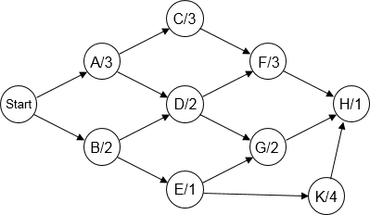

We can convert the activity-node graph to an event-node graph. In an event-node graph, the weight w[u][v] of an edge (u, v) means the time that it takes from event u to event v.

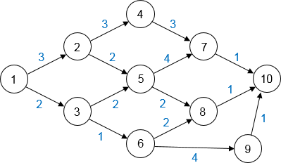

Earliest Completion Time

To find the earliest completion time of the project, we merely need to find the length of the longest path from the first event to the last event. Let ECT[i] be the earliest completion time for node i, then we have:
- ECT[1] = 0,
- ECT[v] = Max (ECT[u] + w[u][v]), where (u, v) ∈ E.

Latest Completion Time

The latest completion time of an event is the time that the event can finish without affecting the final completion time. Let LCT[i] be the latest completion time for node i, then we have:
- LCT[N] = ECT[N],
- LCT[u] = Min (LCT[v] – w[u][v]), where (u, v) ∈ E.

Critical Path

The slack time of an activity is the amount of time that the activity can be delayed without delaying the overall completion. We have SLACK[k] = LCT[k] – ECT[k]. If the slack time of an activity equals to 0, we say that the activity is critical. There is at least one path consisting entirely of 0-slack edges. Such a path is a critical path. To reduce the overall completion, we must consider reducing the time that an activity on the critical path takes. The following shows the critical path in red. Every node is indicated with ECT/LCT/Slack.

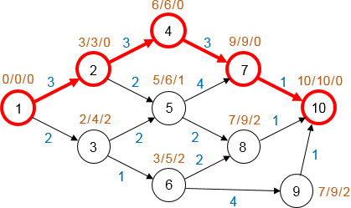

- Network Flow Problem

Given a directed graph G = (V, E) and c[i][j] which represents the capability of edge (i, j). The capability can represent the amount of water that could flow through a pipe or the amount of traffic that could flow on a street. Given two vertices s (source) and t (target), the maximum flow problem is to determine the maximum amount of flow that can pass from s to t.

Starting from the graph G₀, we construct a graph G₁, which tells the flow that has been attained at any stage in the algorithm. Initially, all edges in G₁ have no flow, and we hope that when the algorithm terminates, it contains a maximum flow. We also build a graph G₂, which tells how much more flow can be added for each edge. We can calculate this by subtracting the current flow from the capacity for each edge, i.e. c[i][j] = c₁[i][j] + c₂[i][j]. Initially, G₂ = G₀.

At each stage, we find a path in G₂ from s to t. The minimum edge on this path is the amount of flow that can be added to every edge on the path. We do this by subtracting the corresponding flow from the edges in G₂, and adding the flow to the edges in G₁. We also need to add flow (v, u) in G₂ if we subtract flow (u, v) from it. When we find no path from s to t in G₂, we terminate.

The following shows the graphs G₀, G₁, and G₂ after the path s-a-d-t is selected.

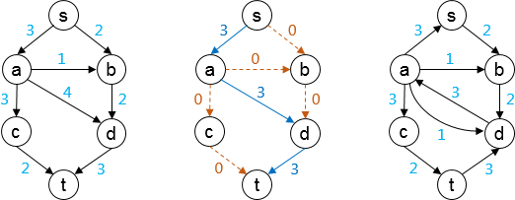

Next, the path s-b-d-a-c-t is selected.

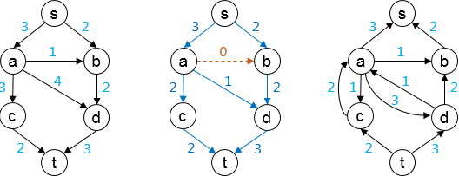

There is no path in the graph G₂ now, so the algorithm terminates. The resulting flow of 5 is the maximum.

